

**Name:** Azan Malik

**ID:** 20006105017

**Program:** BS-IT

**Batch:** 06

**Course:** Advance Web Technologies

**Assignment # 3**

**React TODO List Application**

**Introduction**

This documentation provides an overview of a single-page To-Do List application built using React.js. The application allows users to manage their daily tasks with features such as task addition, completion, deletion, priority categorization, and persistence using local storage.

**Features**

**Task Management:**

Add Task: Users can add new tasks using an input field and select a priority level (High, Medium, Low).

Mark as Complete: Tasks can be marked as completed by clicking a checkbox.

Delete Task: Users can delete tasks from the list.

Edit Task: Double-click on a task to edit its text.

**Persistence:**

The state of the to-do list (tasks and their completion status) is saved to local storage.

The list is populated with saved tasks on application load.

**Bonus Features:**

Clear Completed Tasks: A button to remove all completed tasks.

Priority Categorization: Tasks can be categorized by priority levels (High, Medium, Low).

Animations: Smooth transitions for adding and removing tasks.

**Technical Specifications**

Frontend: React.js

State Management: useState, useEffect

Animations: react-transition-group

Styling: CSS

**Code:**





**Interface:**

**Add Tasks:**

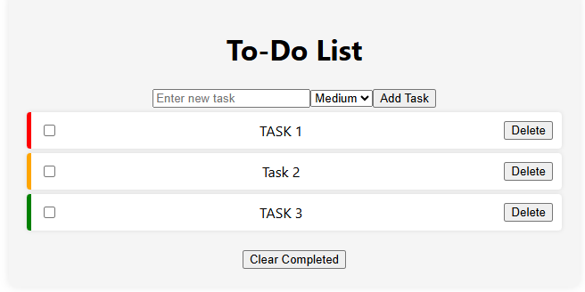

**Update Tasks:**

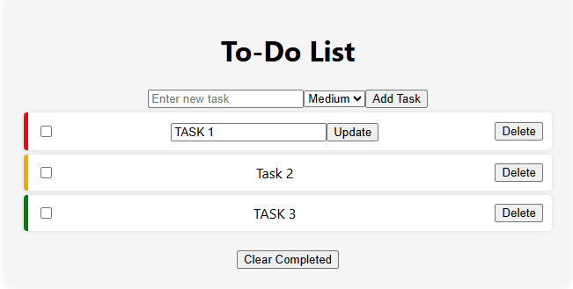

**Complete Tasks:**

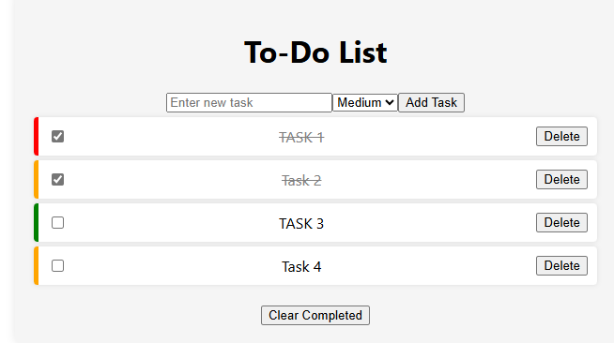

**Clear Tasks:**

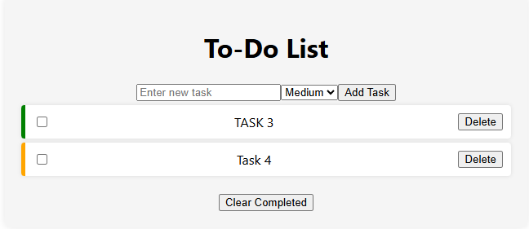

**Priority:**

The priority is shown by colors like red = high, green = low and yellow = medium.

